|  |
| --- |
| **SEDCO**  **CVM TEAM**  **Survey Question Configurator**  **Administrator Installation Guide** |

Table of Contents

Chapter 1: Installation Guide 2

Chapter 2: Uninstallation 6

# Chapter 1: Installation Guide

**1.1 Create & Prepare Database**

Open setup file:

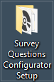

Run Database Script:

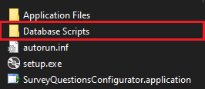



**1.2 Setup the application**

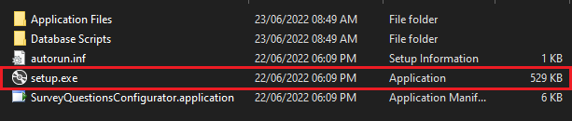

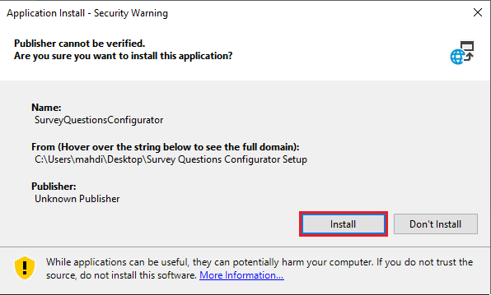

**1.3 Connection Settings**

The application will automatically open.

If not, it can be found in the start menu.

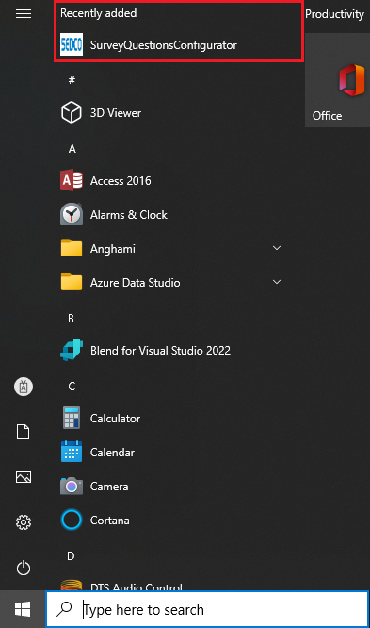

Check connection settings if needed.

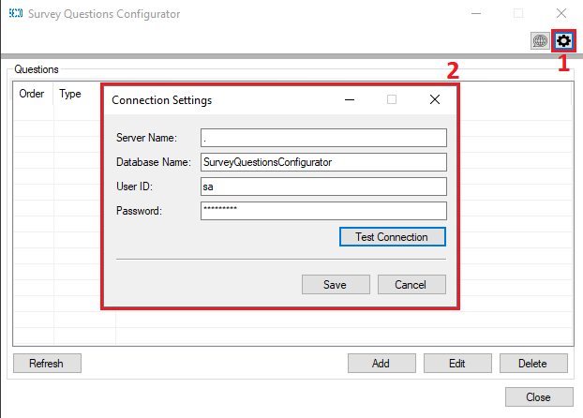

Step 1: Open connection settings

Step 2: Enter connection settings as follows:

1. Server Name: name of the server you want to connect to.
2. Database Name: Name of the database you just created.
3. User Id to be used to connect to the server.
4. Password of the user that want to connect to the server.

# Chapter 2: Uninstallation

**2.1 Uninstallation**

Search for control panel

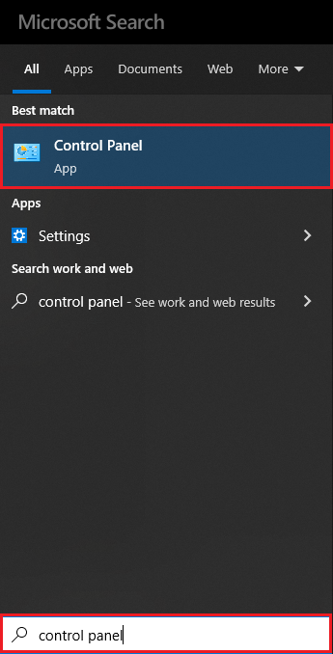

Search for and open programs and features.

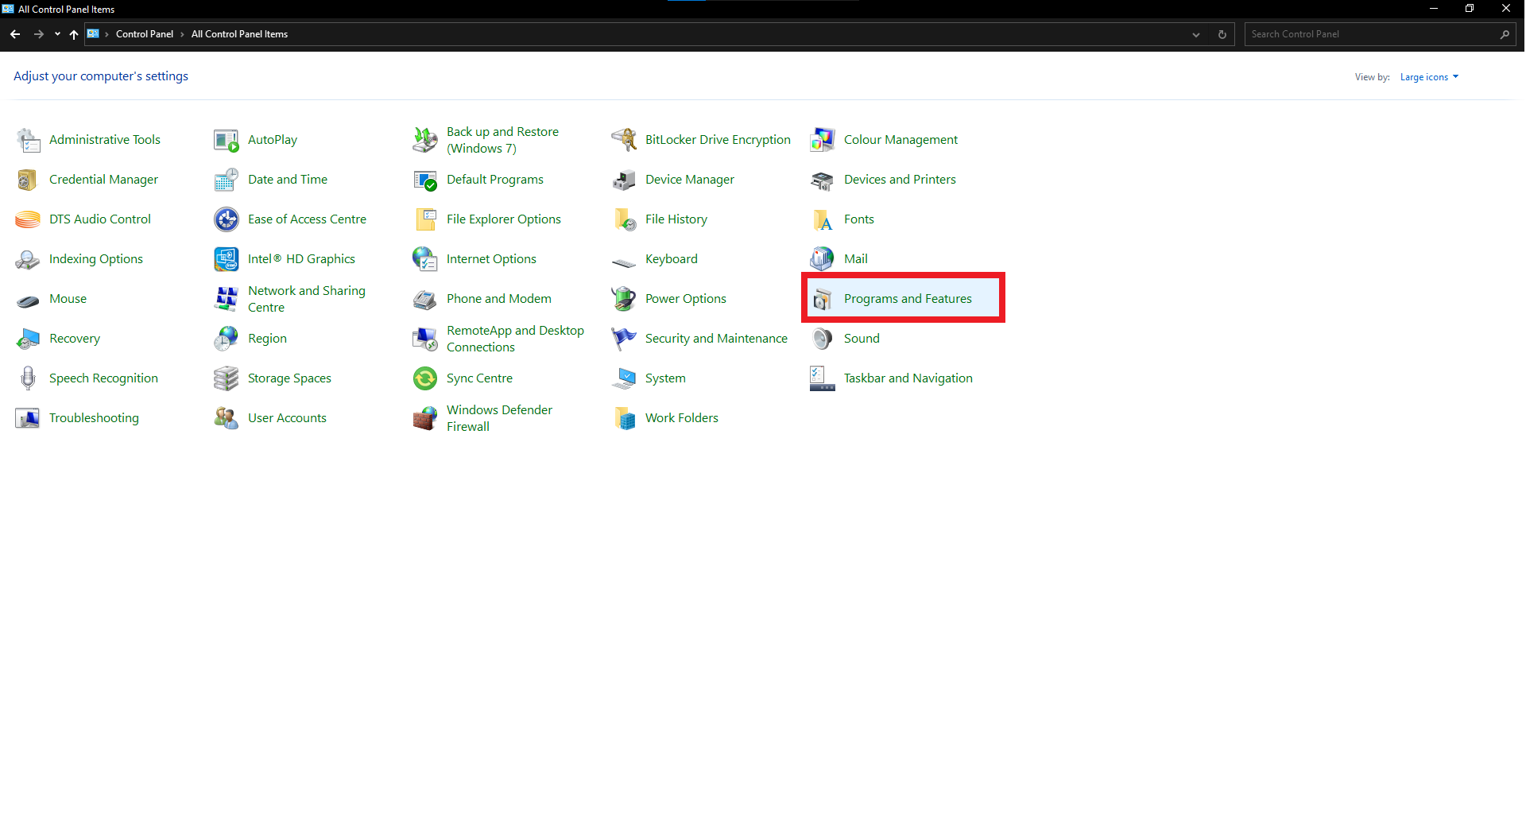

Uninstall the application

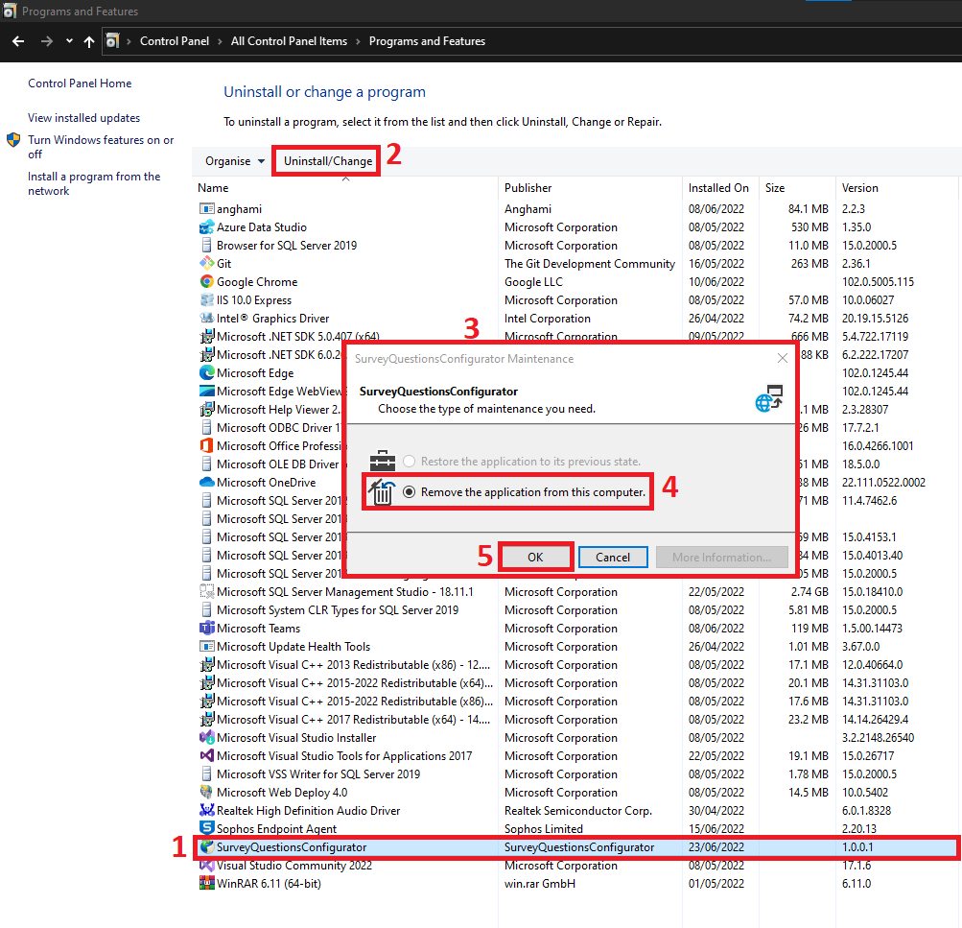

**Steps:**

Step 1: select the application name.

Step 2: click Uninstall/Change.

Step 3: a message will appear.

Step 4: select “Remove the application from this computer”;

Step 5: press “OK”.